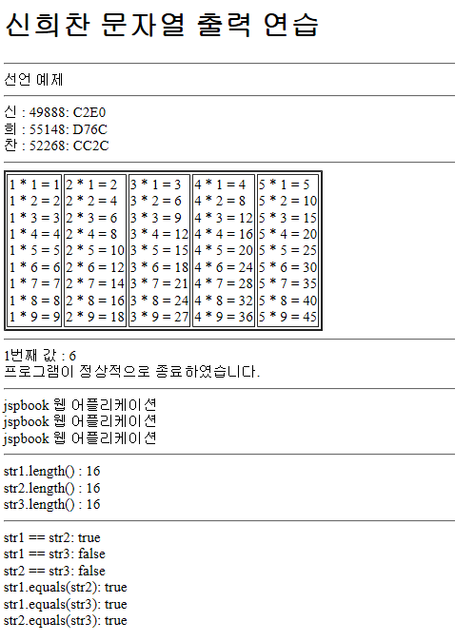

<%@ page language=*"java"* contentType=*"text/html; charset=UTF-8"*

pageEncoding=*"UTF-8"*%>

<!DOCTYPE html>

<html>

<head>

<meta charset=*"UTF-8"*>

<title>201707080 신희찬</title>

</head>

<body>

<h1>신희찬 문자열 출력 연습</h1>

<hr>

선언 예제

<hr>

<%

out.println("신 : " + (**int**)'신' +": C2E0");

out.println("<br>희 : " + (**int**)'희' + ": D76C");

out.println("<br>찬 : " + (**int**)'찬' + ": CC2C");

%>

<hr>

<table border=*2*>

<tr>

<%

**for**(**int** i = 1 ; i<6 ;i++){

out.println("<td>" );

**for**(**int** j = 1 ; j<10 ; j++){

out.println(i + " * " + j + " = " + i*j + "<br>");

}

out.println("</td>");

}

%>

</tr>

</table>

<hr>

<%

**int** i = 0;

**while**(**true**){

**int** n;

n = (**int**)((Math.random()*9)+1);

**if** (n == 7){

out.println("프로그램이 정상적으로 종료하였습니다.");

**break**;

}

**if**((n % 2) == 0){

out.println(i+"번째 값 : " + n + "<br>");

}

i++;

}

%>

<hr>

<%

String str1 = "jspbook 웹 어플리케이션";

String str2 = "jspbook 웹 어플리케이션";

String str3 = **new** String("jspbook 웹 어플리케이션");

out.println(str1+"<br>");

out.println(str2+"<br>");

out.println(str3+"<hr>");

out.println("str1.length() : " + str1.length() );

out.println("<br>str2.length() : " + str2.length() );

out.println("<br>str3.length() : " + str3.length() );

out.println("<hr>str1 == str2: " + (str1 == str2) );

out.println("<br>str1 == str3: " + (str1 == str3) );

out.println("<br>str2 == str3: " + (str2 == str3) );

out.println("<br>str1.equals(str2): " + str1.equals(str2));

out.println("<br>str1.equals(str3): " + str1.equals(str3));

out.println("<br>str2.equals(str3): " + str2.equals(str3));

%>

</body>

</html>